Project Development Phase
Model Performance Test

Date | 30 September 2026
Team ID | 6abab825ad6b12298106a1a8
Project Name | Import Data using Transform Maps (Spreadsheet)
Maximum Marks

Model Performance Testing:
Project team shall fill the following information in model performance testing template.
S.No. | Parameter | Values | Screenshot
 | Model Summary | ServiceNow data import setup using Import Sets, Transform Maps, source fields, target fields and transformed records.  Note : When spreadsheet data matches the configured field mappings and transformation rules, target records are created or updated; otherwise, import errors are reported. | 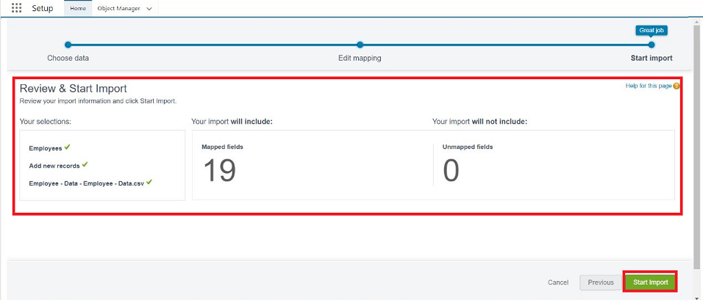
 | Accuracy | Mapping Validation - 100%  Import Validation - 100% | - 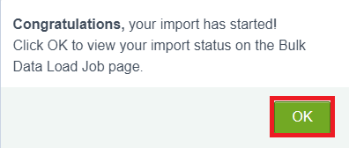
3. | Confidence Score (Only Yolo Projects) | Class Detected - If detecting Object and fields name if wrong and other activity  Confidence Score - If the model is 92% sure the object is correctly detected | 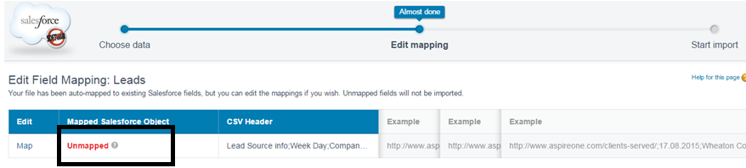  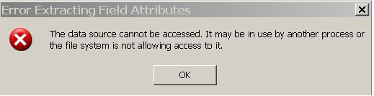

Process Summary: The Transform Map maps spreadsheet source fields to ServiceNow target fields and applies transformation rules during import.
Accuracy / Validation: Validate import accuracy by comparing spreadsheet source values with the resulting ServiceNow target records.
Validation Checks: Verify mandatory fields, reference fields, data types, duplicate handling and transform results.

